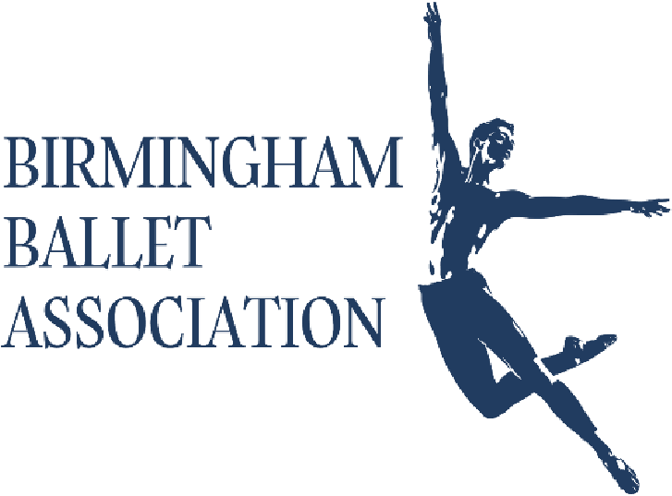
Your Ballet Journey
Awaits
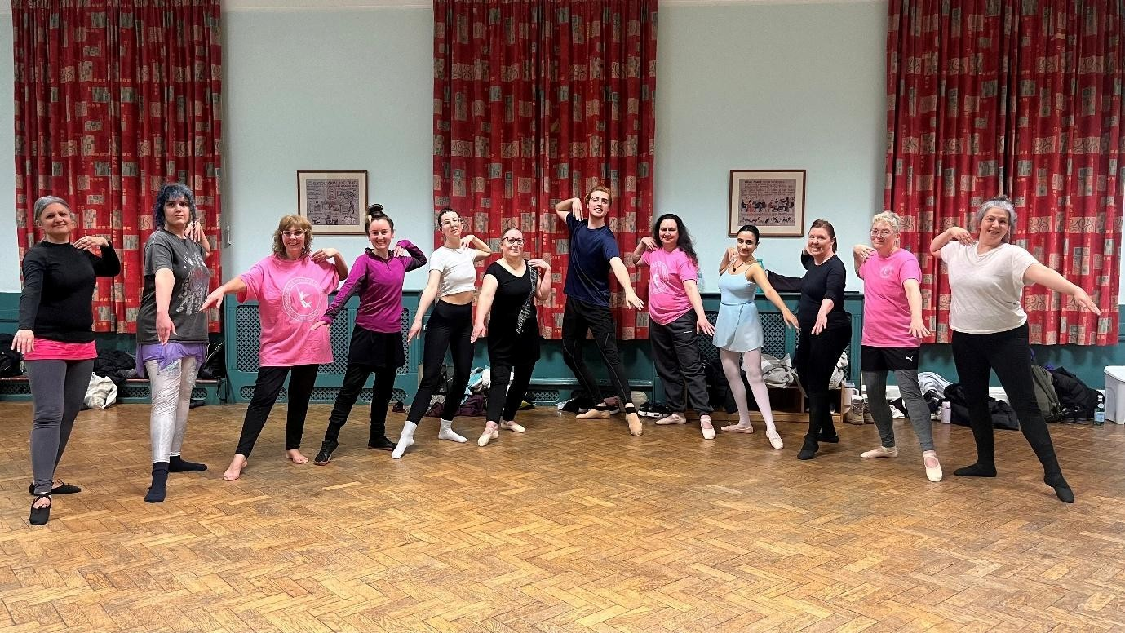

Contents
About the Birmingham Ballet Association 3
About your teacher Alex 3
About Our Taster Sessions 4
Our Next Taster Session Dates 4
Don’t forget to bring 4
Next steps after taster class 4
Harborne Academy (Mon) 5
Rowheath Pavilion (Tue) 5
Shenley Academy (Wed) 5
Rowheath Pavilion (Thu) 5
6-Week Courses 9
Our Ballet Levels 9
Awards & Certification 9
Award Eligibility, Attendance and Progression 10
Booking and Payment Instructions 11
THANK YOU 12

About the Birmingham Ballet Association
The Birmingham Ballet Association is a welcoming community for anyone with a love of ballet—whether you’re a complete beginner, returning to dance or an experienced dancer. Our mission is to bring the joy of ballet to everyone, no matter your age, shape, size or experience.
We offer classes, workshops, and ballet events designed to develop technique, confidence and a love of movement, all in a supportive and friendly environment. Beyond the studio, we aim to connect dancers, build friendships, and create a space where everyone feels included and encouraged.
Whether this is your first class or part of a lifelong journey in dance, we’re thrilled to have you as part of our community!

About your teacher Alex
I was fortunate to train for five years at the Royal Ballet School (White Lodge) and then for another three years at Elmhurst Ballet School. Along the way, I had the privilege of performing alongside the Royal Ballet company, Birmingham Royal Ballet, Ballet Cymru, and a number of other organisations across the UK. These experiences gave me the chance to take part in some incredible productions on stages such as the Royal Opera House, Sadler’s Wells, Opera Holland Park, the Royal Albert Hall (a personal favourite), and of course our very own Birmingham Hippodrome. I’ve also loved travelling around the country to share repertoire workshops and ballet classes with students of all ages.
At 18, I was given the unusual opportunity to join the Royal Academy of Dance’s Professional Dancers’ Teaching Diploma—a programme usually taken later in a dancer’s career. I learned so much from that experience, and it has shaped the way I teach today.
Now, I teach regularly across the West Midlands with organisations including Birmingham
Royal Ballet, the British Ballet Organisation, Stagecoach Kings Heath, Nicholson School of
Dance, and several private schools. I also have a long-term contract as a Ballet Lecturer at BIMM University and founded the Birmingham Ballet Association, which provides structured adult ballet training inspired by international methods. Above all, I aim to bring patience, care, and encouragement to my teaching, helping dancers to progress with focus, confidence, and enjoyment.
I know my dance background might sound a bit intimidating if you’re joining a beginners’ class, but please don’t worry — my classes are welcoming, supportive, and fun. My knowledge of ballet allows me to keep things light and flexible, finding lots of different ways to teach each movement so that no one ever feels stuck.

About Our Taster Sessions
Our Adult Ballet Taster Sessions are designed to:
- Introduce adults to ballet in a fun, accessible and non-intimidating way.
- Encourage movement and physical fitness, improving posture, strength, balance and flexibility.
- Boost confidence and self-expression, allowing you to enjoy the joy of dance regardless of experience.
- Create a welcoming community, where participants of all ages, shapes, sizes and abilities feel included and supported.
- Inspire curiosity and enjoyment, giving you a taste of ballet and perhaps sparking a new hobby or interest.
Above all, the class is about having fun, learning at your own pace and enjoying the experience—there’s no pressure to perform or be perfect.

Our Next Taster Session Dates
Mondays  Harborne Academy  Beginners Ballet: 7-7:55 pm  Beginners Ballet: 7-7:55 pm | Tuesdays  Rowheath Pavilion  Intermediate Ballet: 6-6:55pm  Advanced Ballet – Technique: 7:00-8:10pm  Beginners Ballet 8:15-9:10pm | Wednesdays  Shenley Academy  Ballet Nights – There is no taster session but classes run from 7-9pm | Thursdays  Rowheath Pavilion  Beginners Ballet: 6-6:55pm  Intermediate Ballet: 7-7:55pm  Advanced Corps de Ballet: 8-9:10pm
14th September 2026 | 15th September 2026 | 16th September 2026 | 10th September 2026
2nd November 2026 | 3rd November 2026 | 4th November 2026 | 29th October 2026

Don’t forget to bring
*Water Bottle* *Comfy clothing to put over dance clothes*
*Cash for booking onto our 6-week course or workshops if not paying by bank transfer*

Next steps after taster class
Continue your 6-week ballet course weeks 2-6 from Thursday 15th January onwards; after completing the 6 week course, you will receive a certificate of completion. Once you have completed two 6 week courses (12 weeks) you will also receive a gift and the option to progress with your ballet training to the next level.

Harborne Academy (Mon)
Beginners Ballet: 6-7pm + 7-7:55 pm
Changing facilities and toilets available
Entrance gates will be open to allow you to park cars
On your first visit to the classes, Alex will meet you at the school reception point and walk with you to the main hall.
Please allow time to park and walk up to reception

Rowheath Pavilion (Tue)
Intermediate Ballet: 6-6:55pm
Advanced Ballet – Technique: 7:00-8:10pm
Beginners Ballet 8:15-9:10pm
Toilets available
Parking available for cars
Classes are held in the main hall, simply arrive and Alex will explain where to wait for the following weeks during the introductory talk.
Please allow time to park and walk over to the hall.

Shenley Academy (Wed)
Entrance on Long Nuke Road (Roundabout)
Ballet Nights – 7-9pm
Changing facilities and toilets available
Entrance gates will be open to allow you to park cars
On your first visit to the classes, Alex will meet you at the school reception point and walk with you to the main hall.
Please allow time to park and walk up to reception

Rowheath Pavilion (Thu)
Beginners Ballet: 6-6:55pm
Intermediate Ballet: 7-7:55pm
Advanced Corps de Ballet: 8-9:10pm
Toilets available
Parking available for cars
Classes are held in the main hall, simply arrive and Alex will explain where to wait for the following weeks during the introductory talk.
Please allow time to park and walk over to the hall.

Ballet Etiquette
To create a welcoming, supportive, and focused studio environment:
- Respectful Language: Please use kind, respectful language at all times.
- Supportive Feedback: Feedback is shared constructively. Celebrate your own progress and that of others.
- Positive Environment: Avoid negative comments or comparisons—every body and journey is unique.
- Body Awareness: We work in a mirror-free environments, focusing on how your body moves in space rather than striving for traditional ballet “ideals.”
- Phones & Media: Phones should be silenced. Photos or videos are only allowed if everyone present has given their consent.
- No Talking While Others Are Dancing: This ensures everyone feels comfortable, avoids misunderstandings and allows focus during movement.
- Punctuality & Preparation: Arrive on time and ready to engage fully. Late arrivals can disrupt the class flow.
- Attire: Wear appropriate clothing and secure your hair – See list below.

Childcare Policy
Our ballet classes are designed as a dedicated time and space for adults to focus on themselves, learn and enjoy movement without distractions. To ensure everyone gets the most out of the experience, we kindly ask that no children are brought into the studio or waiting area.
This policy helps maintain a calm and focused environment, where participants can truly switch off and enjoy this special time for themselves.
Unfortunately, we are unable to provide childcare on site. If you are a parent or carer, we encourage you to arrange childcare in advance so you can relax and fully enjoy your class.
Thank you for your understanding and cooperation.

What to wear?
Clothing: (Feel free to mix and match as needed)

Option 1:
- Fitted tank top or athletic top/t-shirt
- Yoga leggings, bike shorts or sports shorts
- Fitted long sleeve top (optional)
- Ballet wrap skirt (optional to wear over leggings or shorts)

Option 2
- Leotard (any style)
- Ballet tights (pink, black, or skin-tone)
- Shorts or a ballet wrap skirt over your tights (please wear for coverage)
- Fitted long sleeve top (optional)

Hair:
- Hair secured away from your face: bun, ponytail, braid, headwrap, or other secure style that works for your hair type.
- Short hair: You can leave it down if it doesn’t fall into your face, or use clips/headbands to keep it neat.
- Protective hairstyles, headscarves, and cultural coverings are welcome, just make sure they are secure and won’t obstruct movement

Ballet Shoes:
If you’re brand new to ballet, you don’t need to rush out and buy shoes before your first class!
For Taster Classes or While You’re Deciding, you can wear socks instead.
When you are ready to commit, Alex stocks black and pink ballet shoes which you are welcome to try on and purchase before or after your lesson. The shoes chosen by Alex are comfortable, offer flexibility for the foot as well as being highly regarded by professional dancers. These are £20.00 and can be paid for by cash or bank transfer in the studio.

Where is the BBA located?
We have 3 locations across the South & West of Birmingham
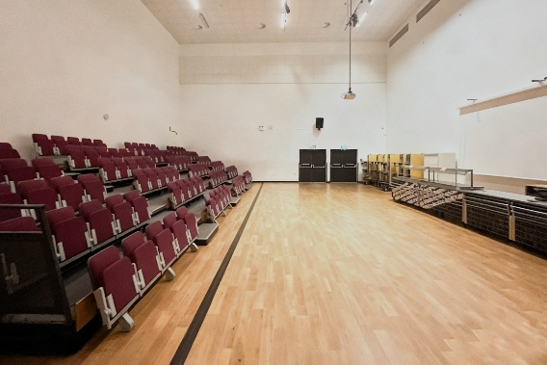 | Harborne Academy, Harborne Rd,  Birmingham B15 3JL
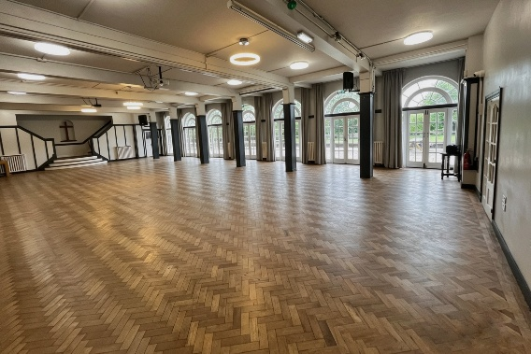 | Rowheath Pavilion, Heath Rd,  Birmingham B30 1HH
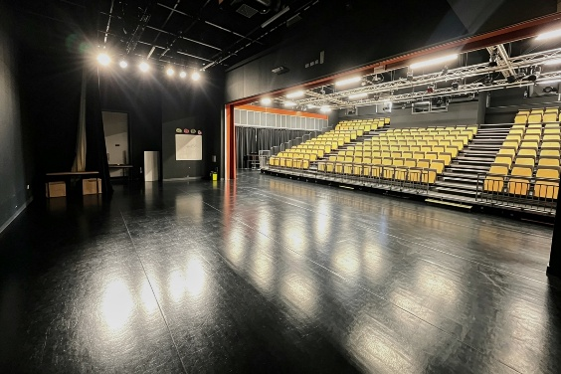 | Shenley Academy, The schools official address is Shenley Ln, Birmingham B29 4HE HOWEVER… use directions to 180 Long Nuke Rd, Birmingham B31 1DY then turn into the school sports hall car park at the roundabout. The classes are held in the MAIN SCHOOL BUILDING

6-Week Courses

Our 6-week courses suit everyone, whether you’re starting fresh, returning to dance or refining existing skills. The courses are designed with set intake times to welcome newcomers, ensuring minimal interruptions and creating an environment optimised for steady learning and, most importantly, having fun.
Typically, for a complete beginner, it takes around 12 months (six consecutive 6-week courses, this includes holidays and breaks) to progress through all levels and reach the Advanced Associates stage. However, you control your journey and can repeat courses at any level as many times as you like to build your skills at your own pace.
The courses are led by Alex, who will provide support throughout your journey. While it’s your personal ballet path, we’re here whenever you need guidance or encouragement.
There are no exams. Progression is based on developing a solid understanding of ballet technique and the opportunity to apply it safely. You will receive clear guidance, supportive feedback, and recognition at every step.

Our Ballet Levels

- Beginners 1+2
- Intermediate Foundation (optional)
- Intermediate 1+2
- Advanced Foundation (optional)
- Advanced 1+2
- Advanced Associates – Corps de ballet

Awards & Certification
Celebrate your progress with our award system, designed to recognise your dedication and achievements without the pressure of exams.

Each award level consists of two 6-week courses, culminating in:
- A Certificate of Achievement at week 6 during a special presentation evening
- A celebration of your progression in ballet at week 12, complete with a thoughtful gift to mark the milestone
These milestones recognise your growing knowledge, confidence, and technical skill as you advance through the levels.

Award Eligibility, Attendance and Progression

When you book your place on the course, you’re committing to our full 6-week course. Each space is valuable and once reserved, it’s no longer available to someone who may be on the waiting list. For this reason, bookings are non-refundable.
In the rare case that we have to cancel a session we will offer an alternate date for the session.
To receive the 6-Week Ballet Award, you’ll need to attend at least 3 sessions.
- If you can’t make a class, please let us know with as much notice as possible.
- If you are away for more than 3 sessions, Please get in touch with Alex to see if he can help schedule an online catch-up session to help with progress, but this may impact your eligibility to receive the 6-Week Ballet Award.
Progression Through Levels
- Each award is made up of two 6-week courses. By completing both, you’ll gain the knowledge needed to progress to the next level.
- To help guide your journey, Alex may suggest which course or level would be the best next step for you.
- Ultimately, you are in control of your own ballet progression. You may choose to move levels at any time within the first two weeks and select whichever level you wish before enrolling in the next course.
We want you to get the very best from your ballet journey — completing every session and both courses in your level is the key to achieving your Ballet Award and progressing with confidence.

Booking and Payment Instructions

To secure your place on the course, bookings can be made either through our website in advance of the classes.
Unfortunately, we’re unable to accept cash payments on the day for new dancers or taster sessions. In the past, this has resulted in no-shows and prevented genuine dancers from accessing limited spaces.
For your peace of mind, we currently have 37 regular dancers enrolled since September, all of whom have successfully booked and paid through our standard systems without any issues. You’re very welcome to meet some of them at our coffee morning—many will be happy to confirm both the authenticity and the friendly spirit of the Birmingham Ballet Association.

Course Pricing
Option 1
Try Week 1 for just £5
If you enjoy the class, you can continue with the remaining course for £57 more (£62 total).
Option 2
Pay £57 for the full 6-week course upfront and save money

Important: Your place is only secured once payment has been received.

THANK YOU

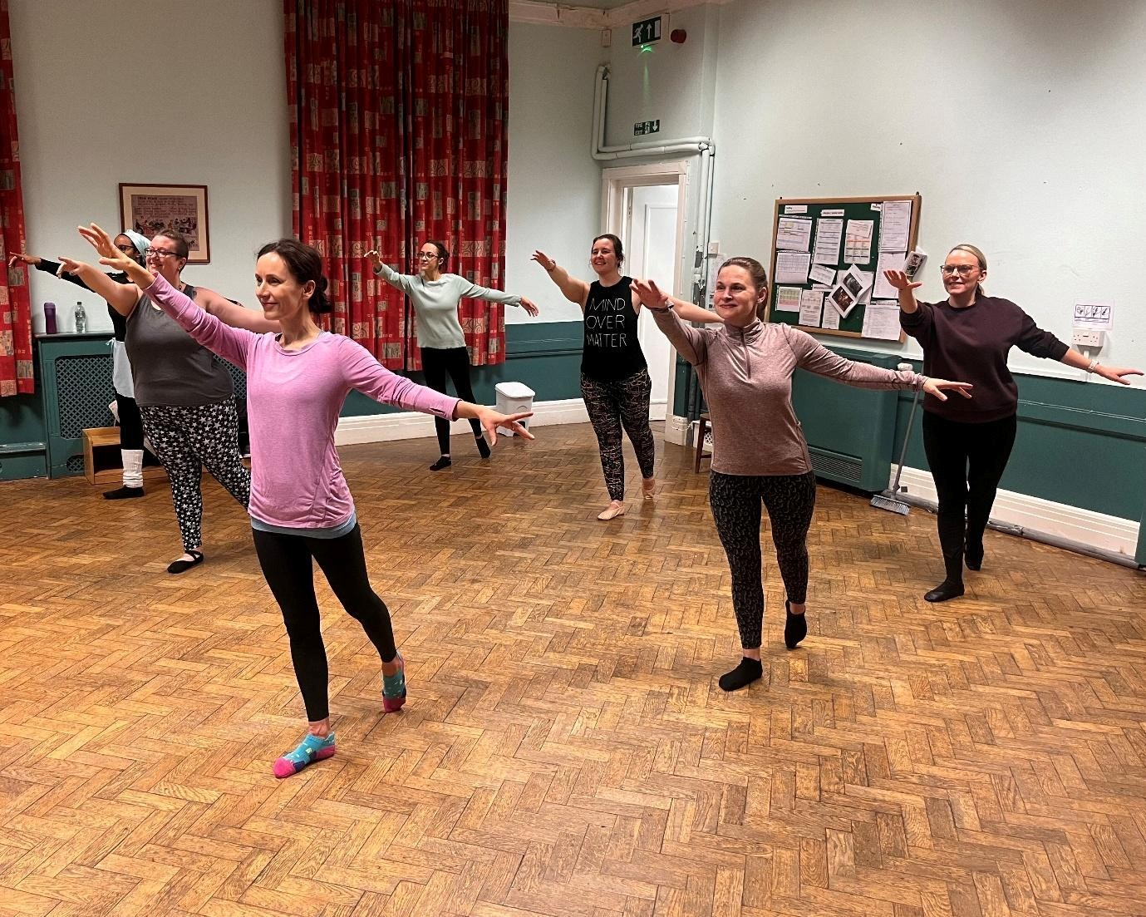

We look forward to dancing with you soon
– Everyone at the Birmingham Ballet Association

bbaballet.co.uk
alex@bbaballet.co.uk

